**Задача 1**

**select**

**extract** (**year** **from** orderdate) **as** order_year,

**extract** (**month** **from** orderdate) **as** order_month,

p3.**name** **as** category_name,

**count**(p3.**name**),

**lag**(**count**(p3.**name**), 1) **over** (**partition** **by** p3.**name** **order** **by** **extract** (**year** **from** orderdate),

**extract** (**month** **from** orderdate)),

**coalesce**(**count**(p3.**name**) - **lag**(**count**(p3.**name**), 1) **over** (**partition** **by** p3.**name** **order** **by** **extract** (**year** **from** orderdate),

**extract** (**month** **from** orderdate)), 0)

**as** change_one_month

**from** salesorderdetail s

**left** **join** salesorderheader s2 **ON** s.salesorderid = s2.salesorderid

**left** **join** product p **on** p.productid = s.productid

**left** **join** productsubcategory p2 **on** p2.productsubcategoryid = p.productsubcategoryid

**left** **join** productcategory p3 **on** p3.productcategoryid = p2.productcategoryid

**where** **date_trunc**('month', orderdate)::**date** **between** '2012-01-01' **and** '2012-03-01'

**group** **by** 1,2,3

**order** **by** 1,2,3

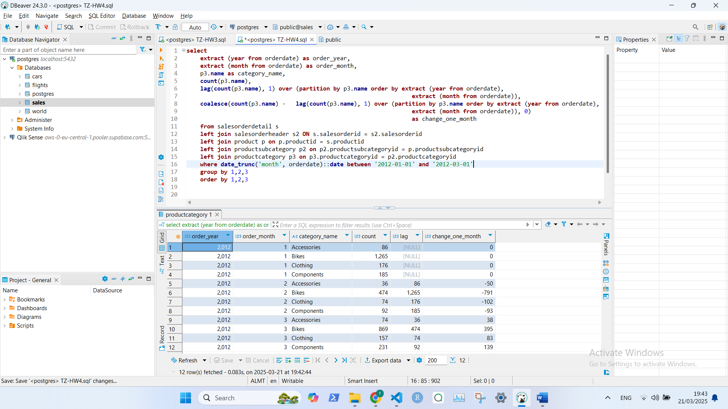

**Задание 2**

select

*p*."name",

sum(*s*.linetotal) as *product_total*,

round(sum(*s*.linetotal)/sum(sum(*s*.linetotal)) over(), 2) as *perc_share*

from salesorderdetail *s*

left join salesorderheader *s2* ON *s*.salesorderid = *s2*.salesorderid

left join product *p* on *p*.productid = *s*.productid

where orderdate between

'2013-01-01 00:00:00' and '2013-12-31 23:59:59'

group by *p*."name"

order by *product_total* desc

limit 10

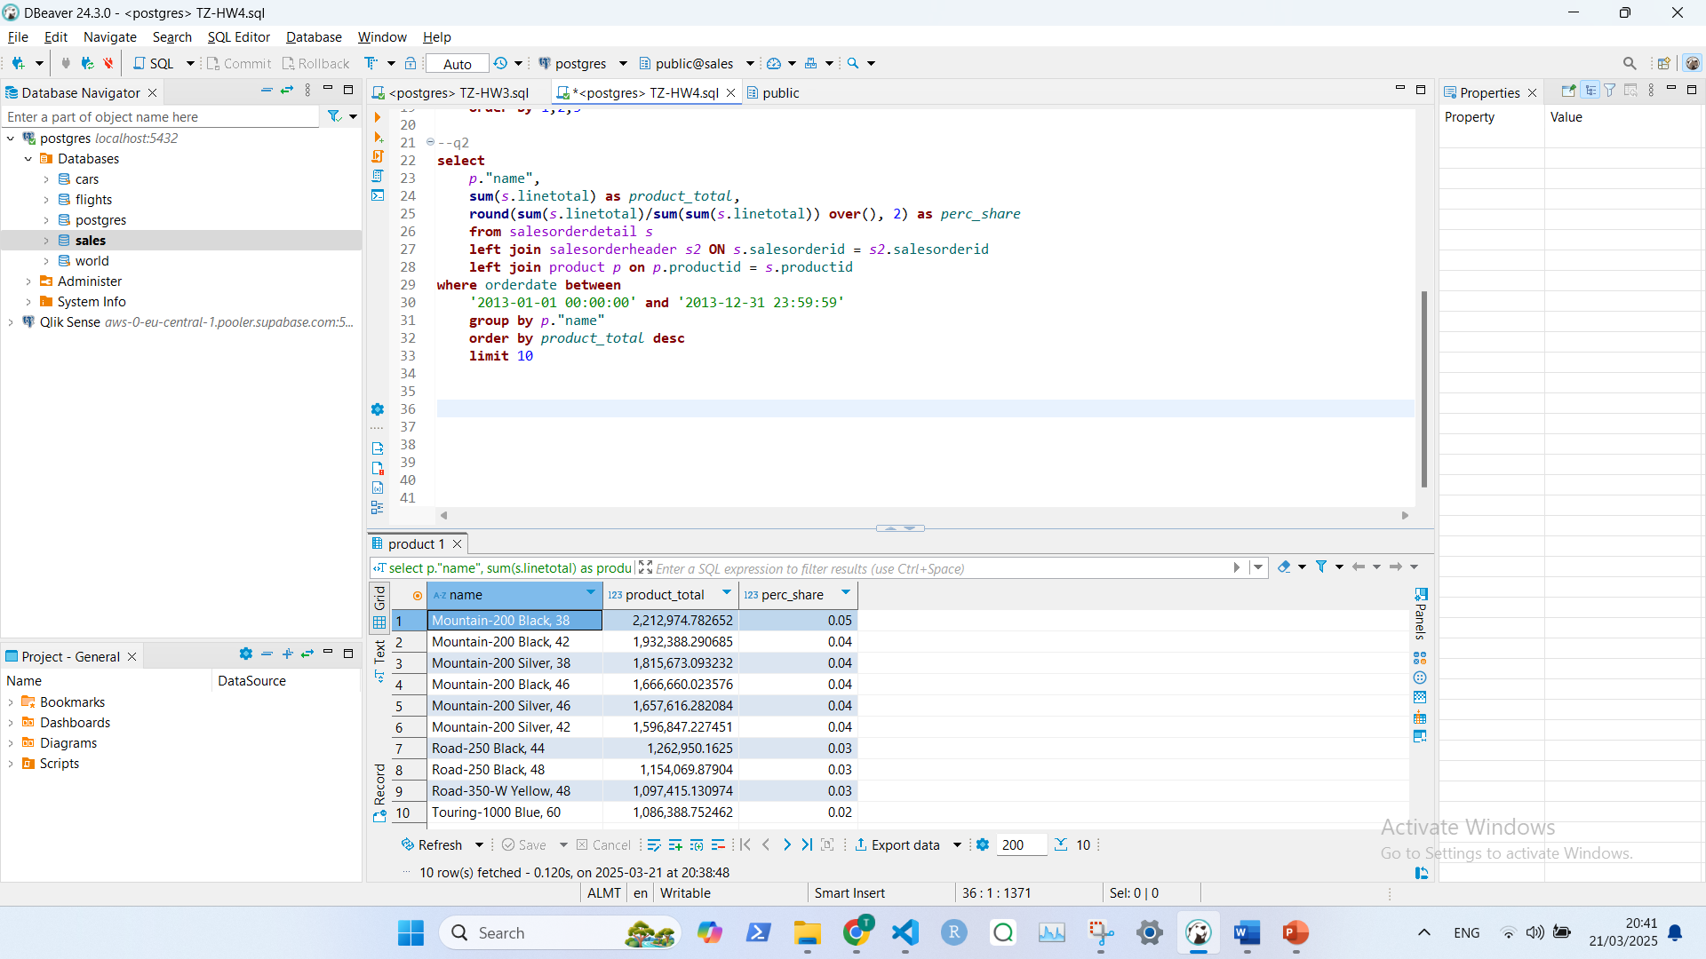

**Задание 3**

*Мои комменты: здесь немного непонятно было, что нужно цеплять s2.shiptoaddressid = a.addressid, названия полей то не совпадают. Я увидел как Кирилл в чате это ответил и в группе мне подсказали, что нужно эти два поля соединять, до этого я получал пустые города, потому что соединял по полю customers.*

**select** **distinct** **on** (s.salesorderid)

s.salesorderid,

**count**(s.productid) **over** (**partition** **by** s.salesorderid) **as** count_products,

a.city,

s2.totaldue,

**sum**(s2.totaldue) **over** (**partition** **by** a.city) **as** totaldue_in_city,

**round**(s2.totaldue / **sum**(s2.totaldue) **over** (**partition** **by** a.city), 2) **as** totaldue_perc,

**max**(s.unitprice) **over** (**partition** **by** s.salesorderid),

**string_agg**(p.productnumber, ', ') **over** (**partition** **by** s.salesorderid) **as** purchased_products

**from** salesorderdetail s

**left** **join** salesorderheader s2 **on** s.salesorderid = s2.salesorderid

**left** **join** product p **on** p.productid = s.productid

**left** **join** address a **on** s2.shiptoaddressid = a.addressid

**where** **date_trunc**('month', orderdate) = '2013-05-01'

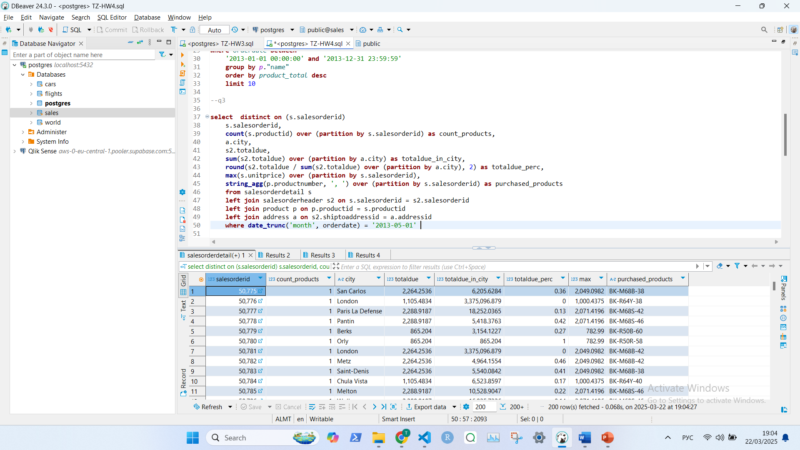

**Задание 4**

**create** **view** s_dict **as** (

**select**

0.8 * **sum**(s.linetotal) **as** s_a,

0.95 * **sum**(s.linetotal) **as** s_b,

**sum**(s.linetotal) **as** s_total

**from** salesorderdetail s

**left** **join** salesorderheader s2 **ON** s.salesorderid = s2.salesorderid

**where** orderdate **between**

'2013-01-01 00:00:00' **and** '2013-12-31 23:59:59')

**select**

*p*."name",

**sum**(*s*.linetotal) **as** *product_total*,

**sum**(**sum**(*s*.linetotal)) **over**(**order** **by** **sum**(*s*.linetotal) **desc**) **as** *srti*,

**case** **when** **sum**(**sum**(*s*.linetotal)) **over**(**order** **by** **sum**(*s*.linetotal) **desc**) <= (**select** s_a **from** s_dict) **then** 'A'

**when** **sum**(**sum**(*s*.linetotal)) **over**(**order** **by** **sum**(*s*.linetotal) **desc**) <= (**select** s_b **from** s_dict) **then** 'B'

**else** 'C'

**end** **as** *test*

**from** salesorderdetail *s*

**left** **join** salesorderheader *s2* **ON** *s*.salesorderid = *s2*.salesorderid

**left** **join** product *p* **on** *p*.productid = *s*.productid

**where** orderdate **between**

'2013-01-01 00:00:00' **and** '2013-12-31 23:59:59'

**group** **by** *p*."name"

**order** **by** *product_total* **desc**

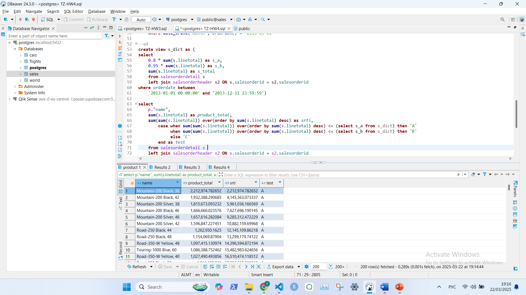

**Задание 5**

**with** *main_table* **as** (

**select**

orderdate::**date** **as** *date*,

**sum**(totaldue) **as** *total*,

**avg**(**sum**(totaldue)) **over**(**order** **by** orderdate

**rows** **between** 4 **preceding** **and** **current** **row**) **as** *total_ma_5*,

**case** **when** **lag**(**sum**(totaldue), 4) **over** (**order** **by** orderdate) **is** **not** **null**

**then** 5\***sum**(totaldue) + 4\***lag**(**sum**(totaldue), 1) **over** (**order** **by** orderdate)+

3\***lag**(**sum**(totaldue), 2) **over** (**order** **by** orderdate) + 2\***lag**(**sum**(totaldue), 3) **over** (**order** **by** orderdate)+

**lag**(**sum**(totaldue), 4) **over** (**order** **by** orderdate)

**when** **lag**(**sum**(totaldue), 3) **over** (**order** **by** orderdate) **is** **not** **null**

**then** 4\***sum**(totaldue) + 3\***lag**(**sum**(totaldue), 1) **over** (**order** **by** orderdate)+

2\***lag**(**sum**(totaldue), 2) **over** (**order** **by** orderdate) + 1\***lag**(**sum**(totaldue), 3) **over** (**order** **by** orderdate)

**when** **lag**(**sum**(totaldue), 2) **over** (**order** **by** orderdate) **is** **not** **null**

**then** 3\***sum**(totaldue) + 2\***lag**(**sum**(totaldue), 1) **over** (**order** **by** orderdate)+

1\***lag**(**sum**(totaldue), 2) **over** (**order** **by** orderdate)

**when** **lag**(**sum**(totaldue), 1) **over** (**order** **by** orderdate) **is** **not** **null**

**then** 2\***sum**(totaldue) + **lag**(**sum**(totaldue), 1) **over** (**order** **by** orderdate)

**else** **sum**(totaldue)

**end** **as** *numerator*,

**case** **when** **lag**(**sum**(totaldue), 4) **over** (**order** **by** orderdate) **is** **not** **null** **then** 15

**when** **lag**(**sum**(totaldue), 3) **over** (**order** **by** orderdate) **is** **not** **null** **then** 10

**when** **lag**(**sum**(totaldue), 2) **over** (**order** **by** orderdate) **is** **not** **null** **then** 6

**when** **lag**(**sum**(totaldue), 1) **over** (**order** **by** orderdate) **is** **not** **null** **then** 3

**else** 1

**end** **as** *denominator*

**from** salesorderheader *s*

**where** **date_trunc**('month', orderdate) = '2013-05-01'

**group** **by** orderdate)

**select** *date*, *total*, *total_ma_5*, *numerator*, *denominator*,

*numerator*/*denominator* **as** *weighted_avg* **from** *main_table*

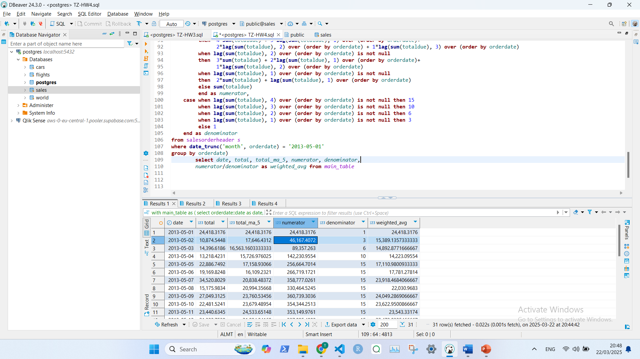

**Задание 6**

*Мои комменты: здесь сделал cross join, чтобы каждый вылет сравнить с каждым вылетом по датам*

**with** *af* **as** (

**select** **distinct**

flight_id,

actual_departure *at* **time** **zone** 'Europe/Moscow' **as** start_dttm,

actual_arrival *at* **time** **zone** 'Europe/Moscow' **as** end_dttm

**from** bookings.flights

**where** (actual_departure **at** **time** **zone** 'Europe/Moscow')::**date** = '2017-02-01')

**select**

*af*.start_dttm,

*af*.end_dttm,

**count**(*f*.flight_id) **filter** (**where** f.actual_departure **at** **time** **zone** 'Europe/Moscow' <= af.start_dttm

**and** f.actual_arrival **at** **time** **zone** 'Europe/Moscow' >= af.start_dttm) **as** *flights_air_cnt*,

**count**(*f*.flight_id) **filter** (**where** f.actual_arrival **at** **time** **zone** 'Europe/Moscow' <= af.start_dttm) **as** *flights_finished_cnt*

**from**

*af* **cross** **join**

bookings.flights *f*

**where**

(*f*.actual_departure **at** **time** **zone** 'Europe/Moscow')::**date** = '2017-02-01'

**group** **by** *af*.flight_id, *af*.start_dttm, *af*.end_dttm

**order** **by** *flights_air_cnt* **desc**

